Question 1)-

* SOURCE /Users/sberk/Desktop/Spring 2023/COMP306/HW2/world.sql
* show databases;



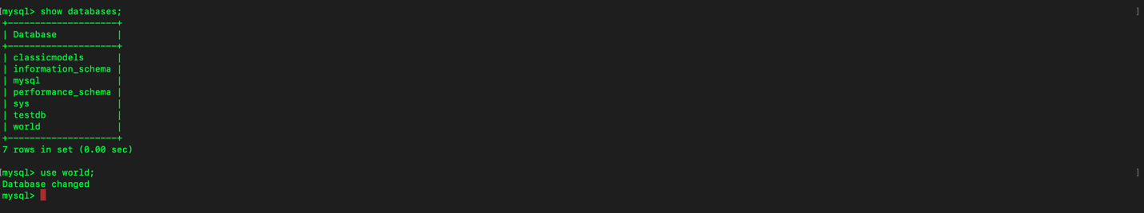

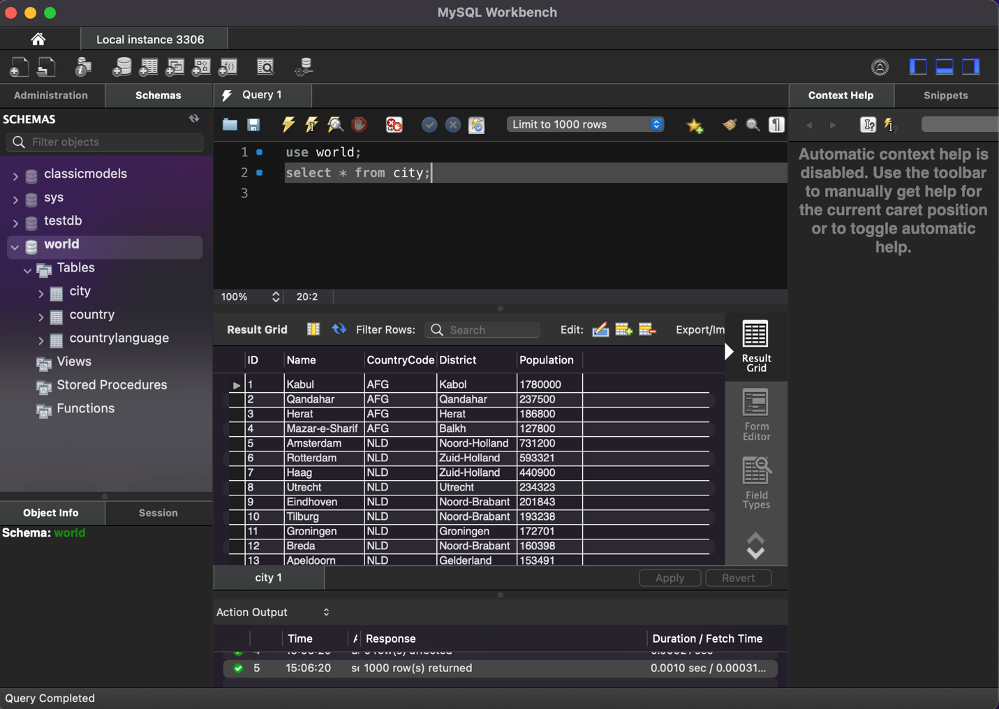

Question 2)-

Part a.

* SELECT Name, GNP FROM Country WHERE Continent=”Europe” and IndepYear > 1930;

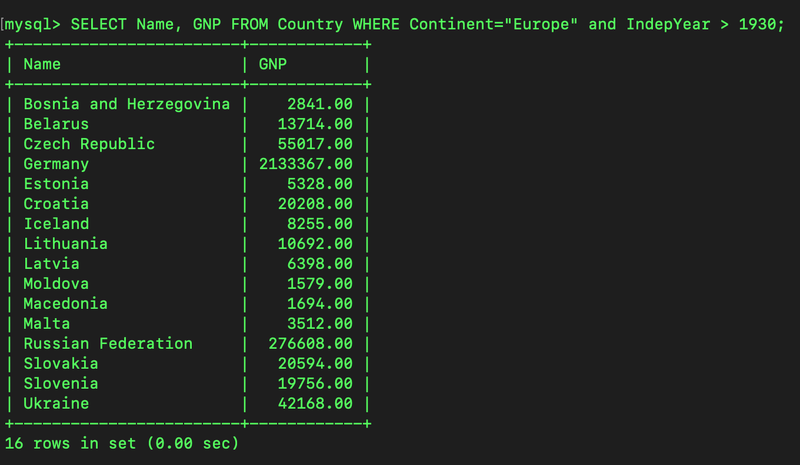

Part b.

* SELECT Country.Code, Country.Name as CountryName, City.Name as CityName, City.Population FROM Country, City WHERE Country.Code=City.CountryCode and Country.LifeExpectancy > 75 and Country.Population < 1000000;

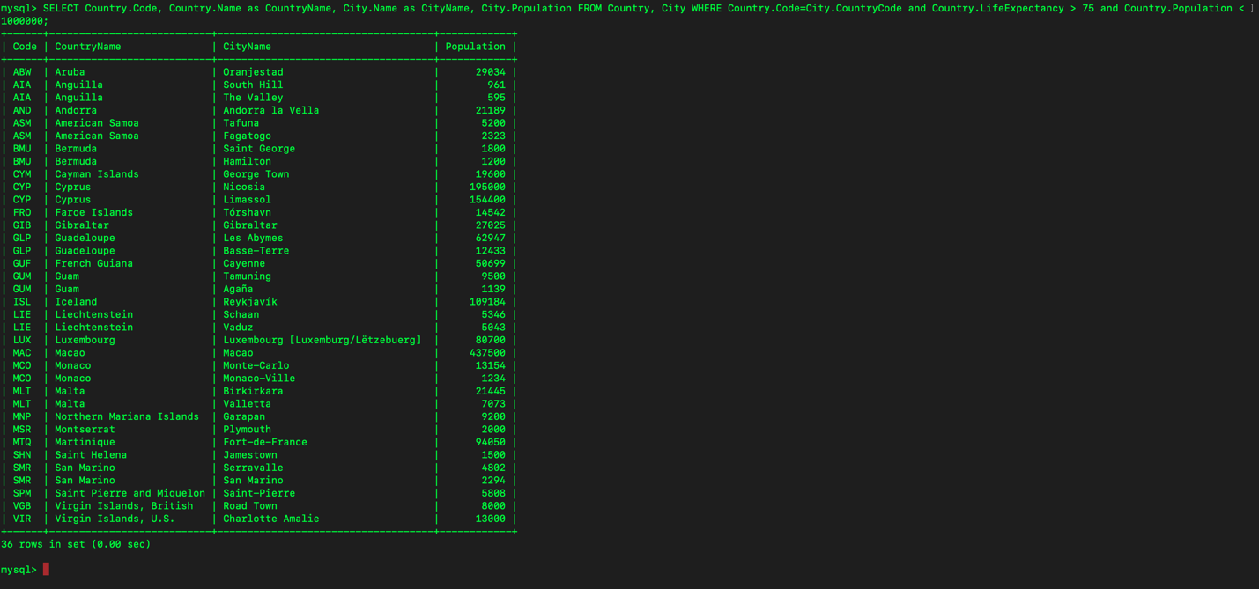

Part c.

* SELECT DISTINCT Language FROM country, countrylanguage WHERE country.code=countrylanguage.CountryCode and country.SurfaceArea > 1000000 and countrylanguage.Percentage > 50;

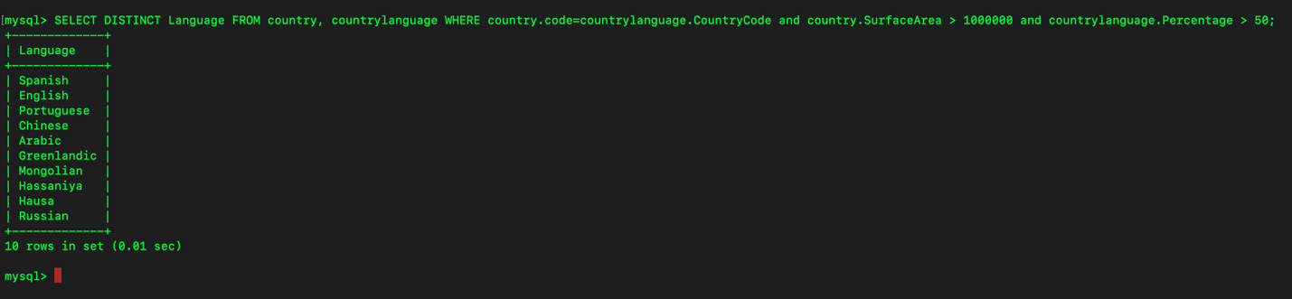

Part d.

* SELECT city.CountryCode, city.Name as CityName FROM city, country, countrylanguage WHERE city.CountryCode=country.Code and country.Code=countrylanguage.CountryCode and city.population < 90000 and countrylanguage.Language="German" and countrylanguage.Percentage > 1;

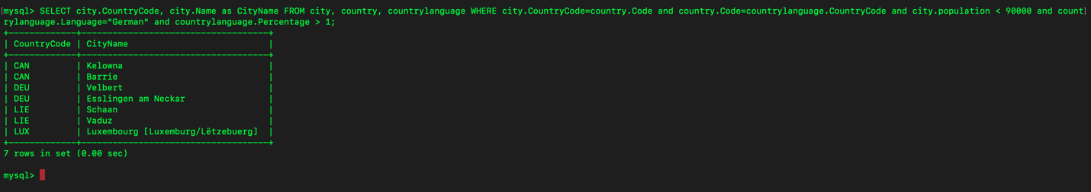

Question 3)-

Part A.

* I could not make sure that if restaurants must have only ids or it must have ids, names, and type. I did according to my intuition all restaurants must have ids, names, andt type.
* CREATE TABLE restaurant(
* -> r_id int NOT NULL,
* -> r_name varchar(50) NOT NULL,
* -> r_type varchar(15) NOT NULL,
* -> r_rating int CHECK(r_rating between 1 and 5),
* -> primary key(r_id)
* -> );

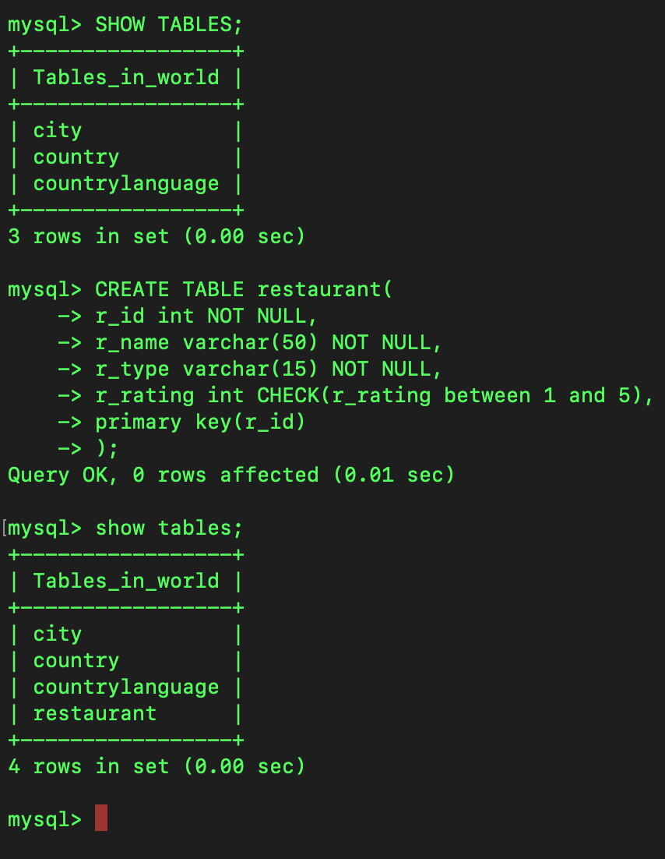

Part B.

* INSERT INTO restaurant
* -> values
* -> (1, "Kebo Doner Antakya", "Hatay Food", 5);

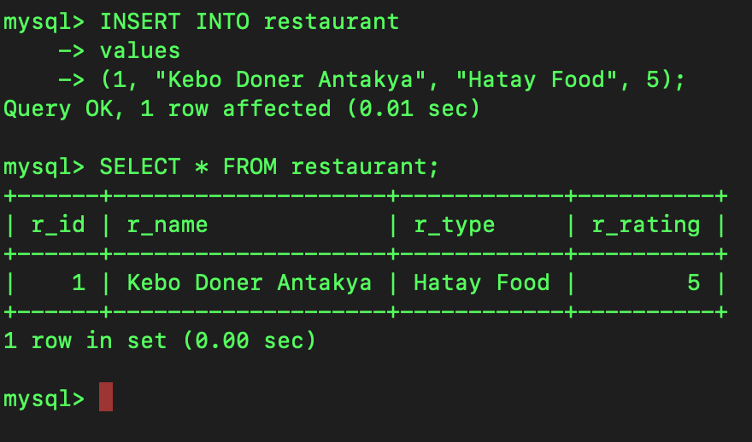

Part C.

* INSERT INTO restaurant
* -> values
* -> (2, "El Taquito Loco", "Mexican", 4),
* -> (3, "The Greek Taverna", "Greek", 5),
* -> (4, "The Wok Inn", "Chinese", 3),
* -> (5, "La Pizzeria Bella", "Italian", 4),
* -> (6, "The Tap House", "Pub Food", 3),
* -> (7, "Bao Bun House", "Asian Fusion", 4),
* -> (8, "The Vegan Kitchen", "Barbecue", 4),
* -> (9, "La Brasserie Belge", "Belgian", 4),
* -> (10, "The Smokestack BBQ", "Barbecue", 4),
* -> (11, "Sushi Island", "Japanese", 3);

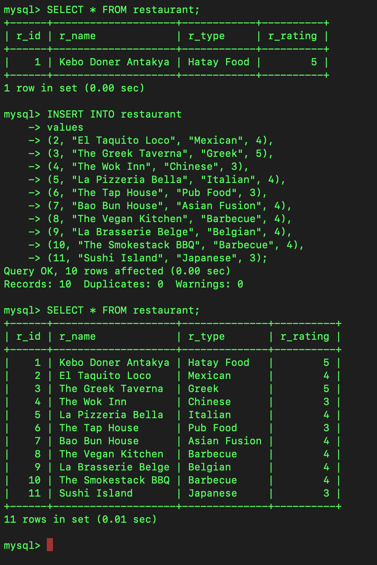

Part D.

* UPDATE restaurant
* -> set r_type="Vegan"
* -> WHERE r_name="The Vegan Kitchen";

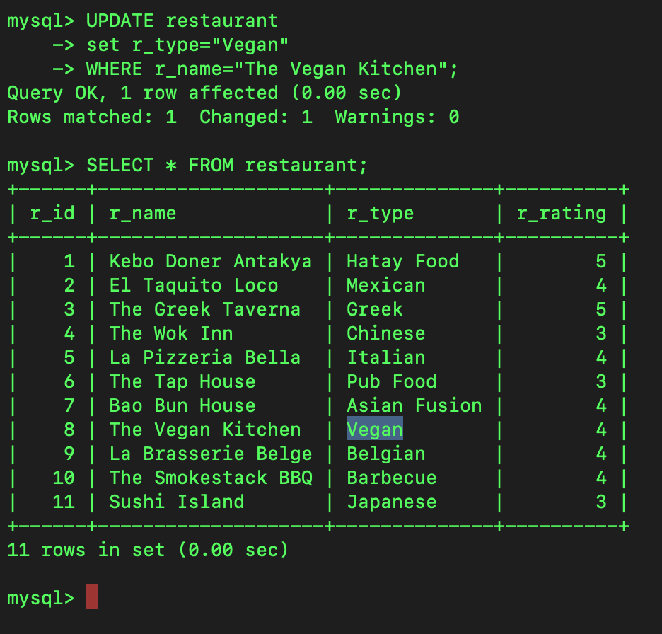

Part E.

* DELETE FROM restaurant WHERE r_name="The Tap House";

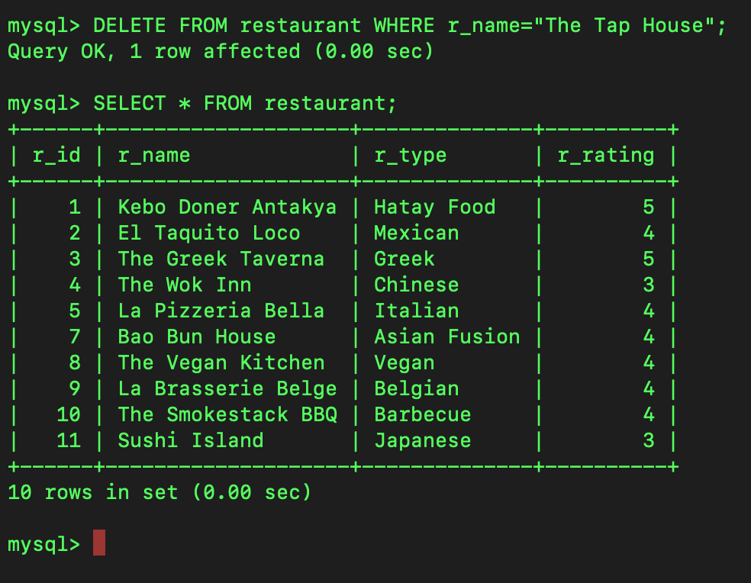

Question 4)-

Part A.

* CREATE TABLE city_restaurant(
* -> restaurant_id int NOT NULL,
* -> city_id int NOT NULL,
* -> PRIMARY KEY (restaurant_id, city_id),
* -> FOREIGN KEY (restaurant_id) REFERENCES restaurant(r_id),
* -> FOREIGN KEY (city_id) REFERENCES city(ID)
* -> ON UPDATE CASCADE ON DELETE RESTRICT);



Part B.

* load data local infile "/Users/sberk/Desktop/Spring 2023/COMP306/HW2/city_restaurant.txt" INTO TABLE city_restaurant;

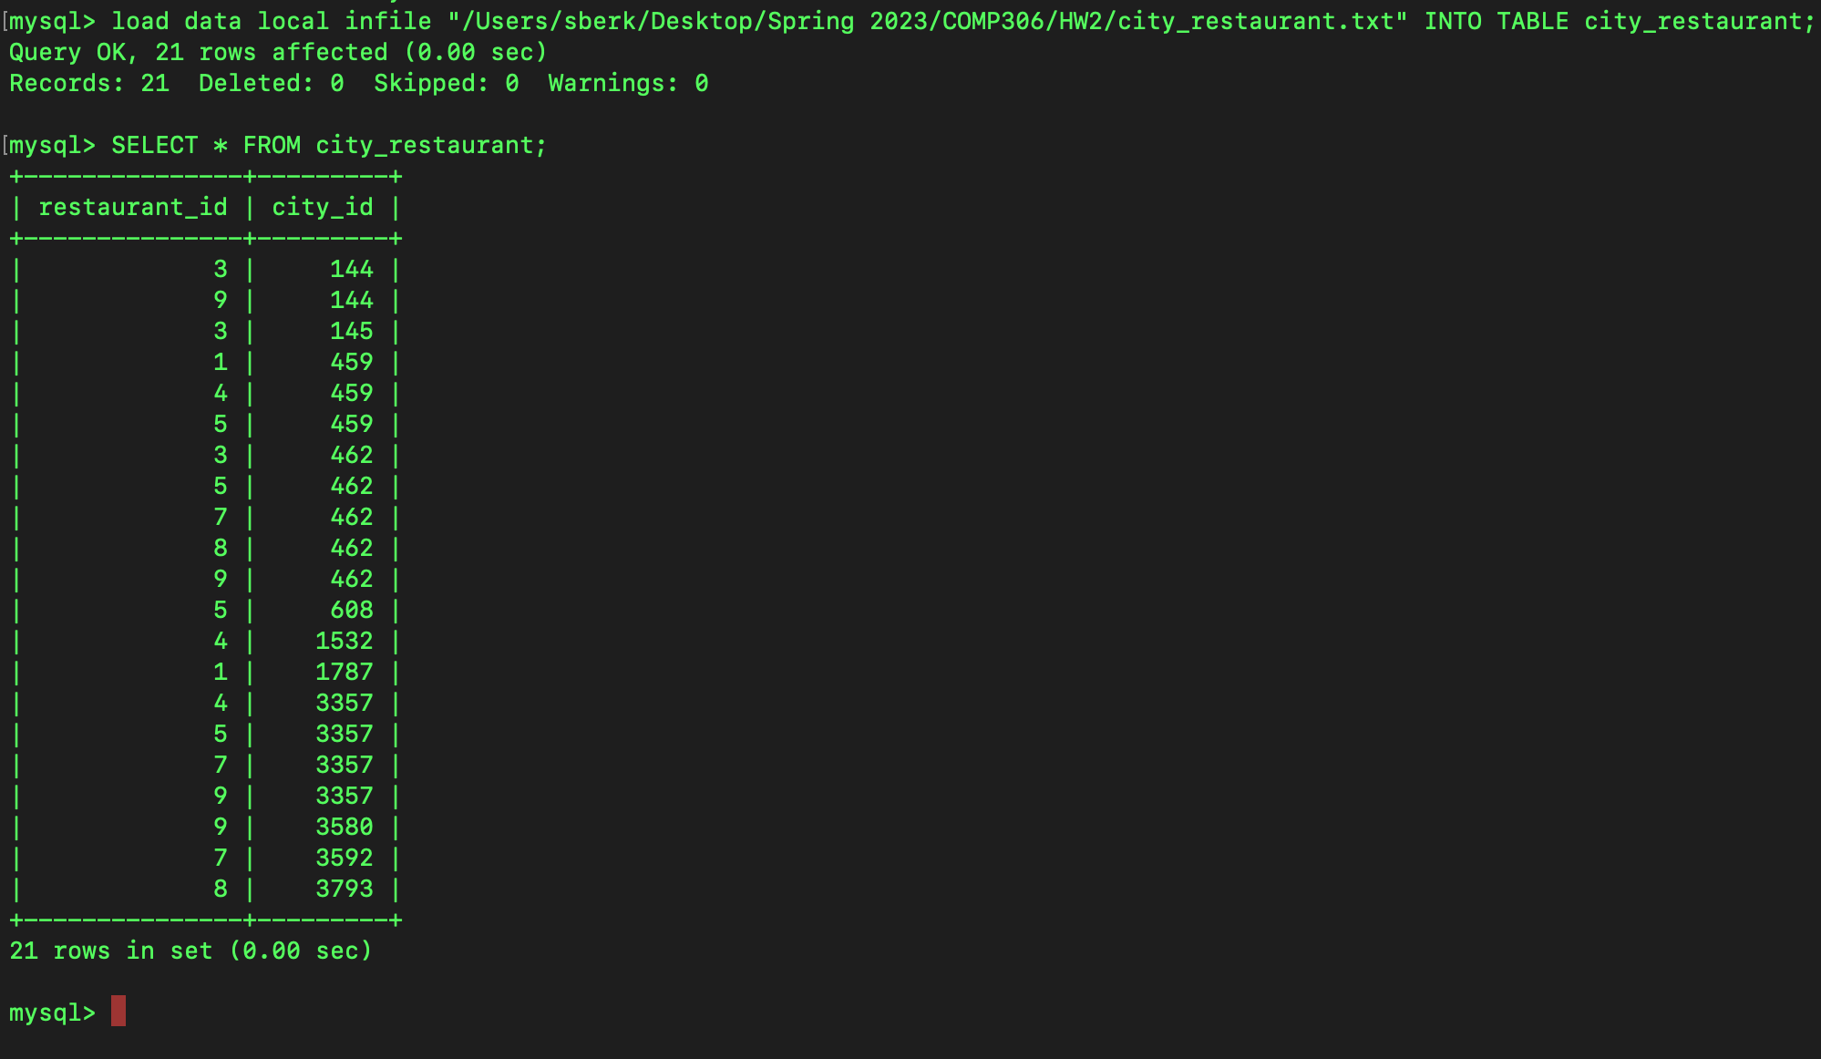

Part C.

* SELECT city_id, city.Name as cityName FROM city_restaurant, city WHERE city.ID=city_restaurant.city_id GROUP BY city_id HAVING COUNT(*) > 1;

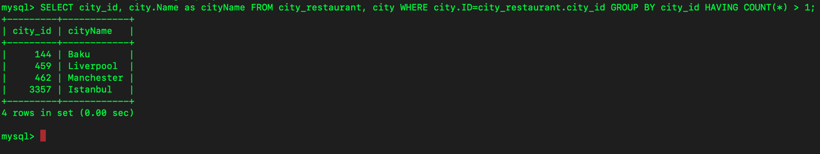

Part D.

* SELECT restaurant.r_id, restaurant.r_name FROM city, city_restaurant, restaurant WHERE city.ID=city_restaurant.city_id and city_restaurant.restaurant_id=restaurant.r_id and city.Name="Manchester" EXCEPT (SELECT restaurant.r_id, restaurant.r_name FROM city, city_restaurant, restaurant WHERE city.ID=city_restaurant.city_id and city_restaurant.restaurant_id=restaurant.r_id and city.Name="Liverpool");

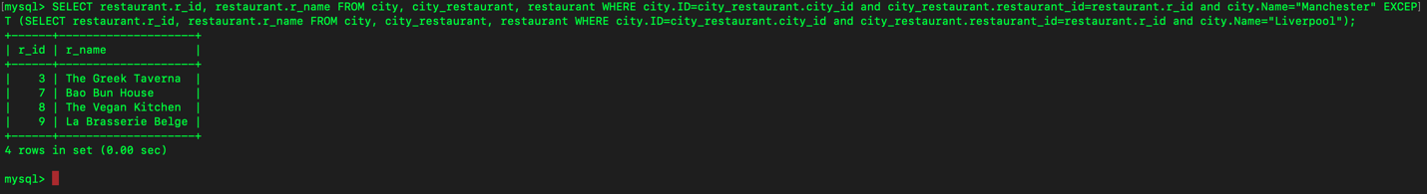

Part E.

* SELECT restaurant.r_id, restaurant.r_name FROM city, city_restaurant, restaurant WHERE city.ID=city_restaurant.city_id and city_restaurant.restaurant_id=restaurant.r_id and city.Population > 100000;

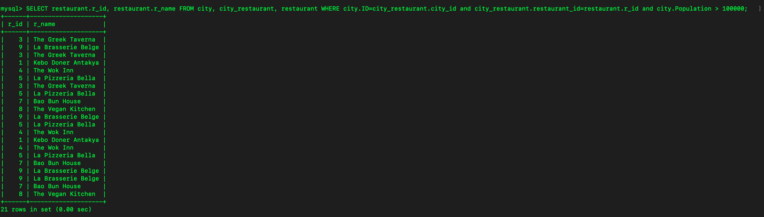

Distinct Solution for Part E:

* SELECT DISTINCT restaurant.r_id, restaurant.r_name FROM city, city_restaurant, restaurant WHERE city.ID=city_restaurant.city_id and city_restaurant.restaurant_id=restaurant.r_id and city.Population > 100000;

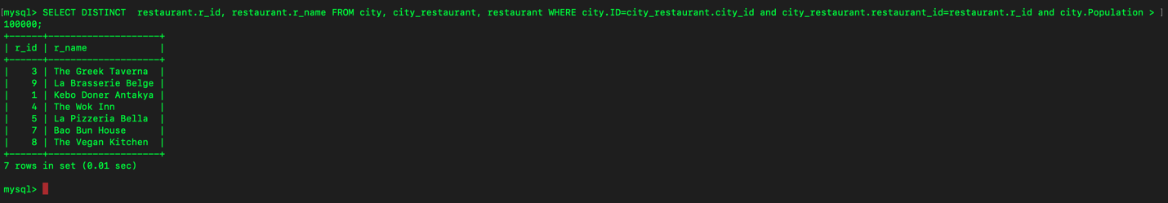

Part F.

* SELECT restaurant.r_id, restaurant.r_name FROM country, city, city_restaurant, restaurant WHERE country.Code=city.CountryCode and city.ID=city_restaurant.city_id and city_restaurant.restaurant_id=restaurant.r_id and country.Name="Azerbaijan" GROUP BY r_id HAVING COUNT(*) > 1;

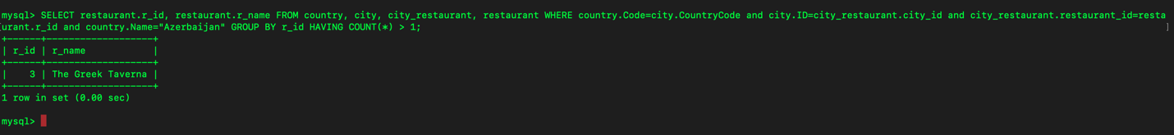

Part G.

* SELECT DISTINCT * FROM country WHERE country.Code NOT IN (SELECT DISTINCT country.Code FROM country, city, city_restaurant, restaurant WHERE country.Code=city.CountryCode and city.ID=city_restaurant.city_id and city_restaurant.restaurant_id=restaurant.r_id);

Note that there is no duplicates in the output. Because of the long result to be able to visualize I took my screeenshot such that each of the next screenshot begins with the output that is ended in previous output.

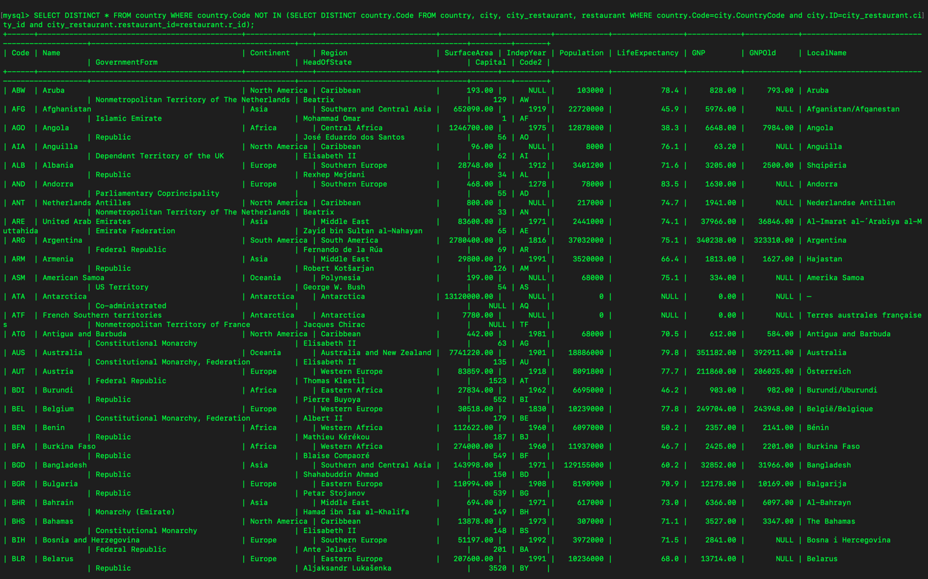

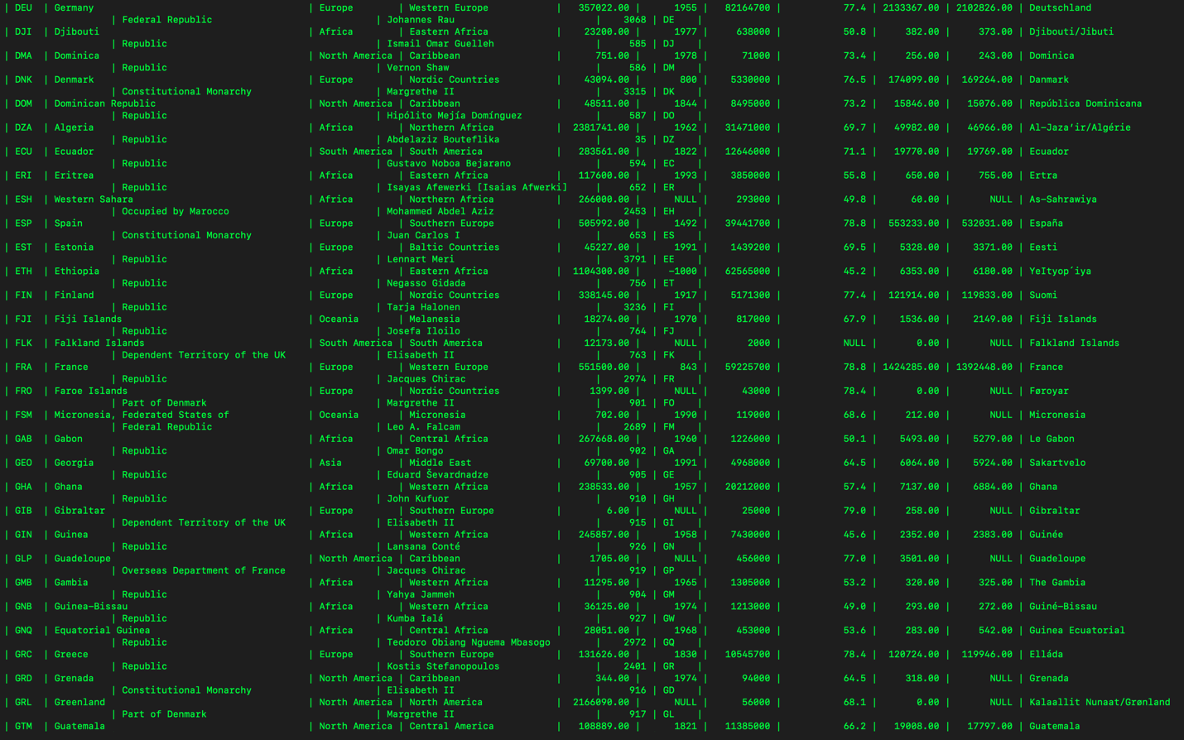











Question 5)-

* ./mysqldump -u root -p world > /Users/sberk/Desktop/world-export.sql